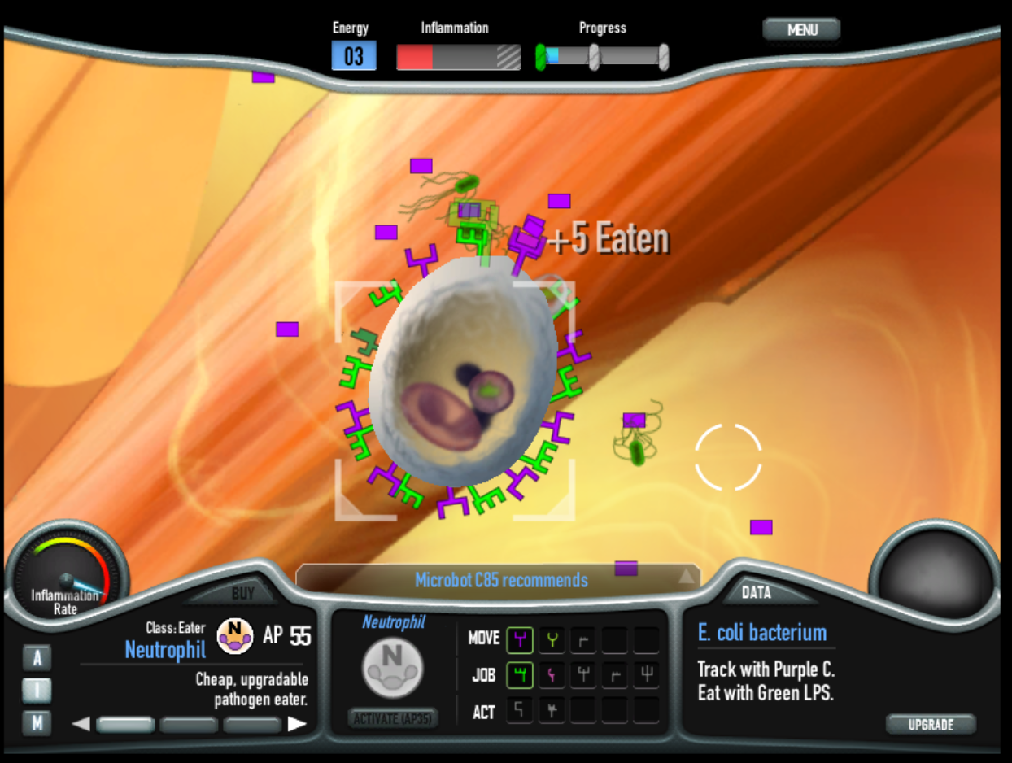
Immune Defense is a strategy game in the inner space of your own body. The engaging game mechanic drives player confidence by providing a clear set of possible actions and new, interesting challenges. The player buys cells, equips them with receptors. Each cell type has its own complement of receptors, and by changing them the player can move cells into strategic positions, activate cells at key moments and clear infections. The player wins by clearing the infection with a lower inflammation level than the body would have managed alone.

Immune Defense lets players experiment with fundamental concepts in molecular biology, including diffusion, randomness, protein structure and function, cell differentiation and cell behavior. Immune Defense was designed based on our research with our first molecular biology video game. Our controlled experiments demonstrate that players remember the names, appearance and functions of cells and proteins. Additionally, our players show increased confidence with molecular cell biology diagrams, compared to their classmates.

52% of high school students thought they would not be able to understand the diagram on the right; playing our game cut that number in half. One day after playing our game or a control game, students were shown the diagram on the right and asked to agree or disagree with this statement: “I would be able to understand this diagram if I read it and thought about it.” 1 = I disagree, 5 = I agree. Average scores were Molecular biology game = 3.16 and Control = 2.50. Students T-Test p <<0.000.
Citation: Stegman, M. Immune Attack players perform better on a test of cellular immunology and self confidence than their classmates who play a control video game. Faraday Discussions, 2014. 169:403-423.

Melanie Stegman, Ph.D. MolecularJig@gmail.com Molecular Jig Games, LLC.

Immune Defense is a free mini game for web, PC, Mac and Linux. Support our work and pre-purchase the full game at ImmuneDefenseGame.com.

