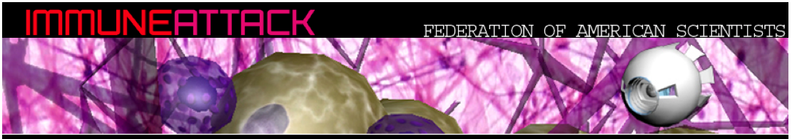
Get started:
1. Download Game http://dvfwe9diopsib.cloudfront.net/ImmuneAttackSetup.exe
2. Install the game by following the instructions.
3. Click on the Immune Attack icon on your desktop to start the game.
4. After the video, hit Enter for Main Menu.
(To get to the main menu while playing, click on Pause in Lower Right, then click on Quit to Main Menu.)

Adjust sound:
5. At the Main Menu, choose OPTIONS to adjust sound.

Be invincible:
6. At the Main Menu, choose INSTRUCTOR MENU.
7. Password is “abc.” Type abc and hit Enter.
8. Click on “Can Be Damaged” to be “Invincible.”

***Immune Attack 1.0 does not have a save function.***

To start game at any level:
9. At Main Menu, choose INSTRUCTOR MENU.
10. Type abc for password and hit Enter.
11. Choose “Jump to any level”
12. Choose level.
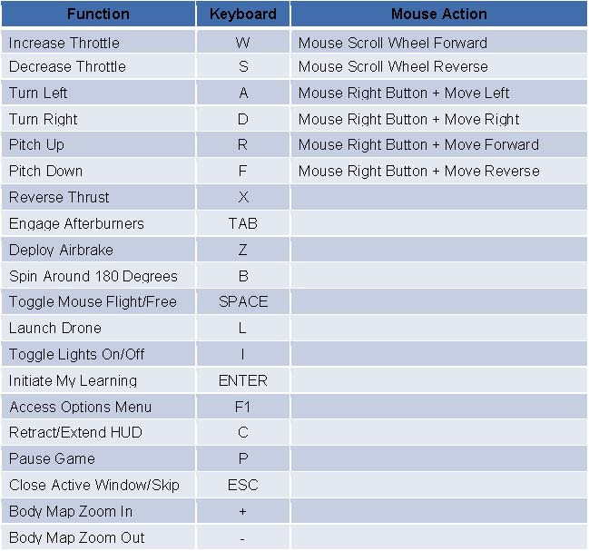
Give us your feedback!
Players: http://iaplayers.questionpro.com/
Teachers: http://iateacher.questionpro.com/

Immune Attack. Bloodiest Game Ever

ImmuneAttack.org
LearningTech@FAS.org

SYSTEM REQUIREMENTS:
Windows XP SP2,
2Ghz processor (1.6Ghz works, just slower)
1MB Ram,
64 MB Video Card,
2 button mouse.

Do not use a joystick or any other game attachment.

Your video card must be compatible with Direct X.
GAME WALK THROUGH
The following outline will guide you through the first 2 Missions of Immune Attack. However, everything is explained in the game, and listening, learning and discovering are part of the fun!

Mission 1. Teaching Monocytes to Transmigrate:
13. After basic training, you must go find the “data packet” that contains your drones and mission briefing. Look for the blue dot on the mini map, and navigate the Nanobot through the guide rings. Fly right up to the blue packet. Drones are protein sized mini ships that let you interact with molecules.
14. Navigate to the site of infection (Blue spot in the Mini Map).
15. Monocytes are supposed to be responding to the infection, but they aren’t! Why not? Listen to your colleagues’ advice, watch the video that explains what Transmigration is. In the video you see that Selectin and ICAM proteins are being presented by cells of the blood vessel wall, and usually Monocytes stick to Selectins, causing the Monocytes to slow down and roll along the wall. However, our Monocytes don’t see the Selectins. Our job is to use the Nanobot’s ray gun to “mark” the Selectins. (Selectins are yellow. Use left mouse button to “mark.”) After you mark 1 Selectin, the Monocyte slows down and floats to that Selectin. You mark 5 more Selectin, in front of the Monocyte, and the Monocyte will slowly roll over those Selectins. ONLY AFTER the Monocyte has actually reached the 6 Selectins will the game pause and give you more instructions.
16. The game pauses and your colleagues give verbal instructions telling you to mark an ICAM (brown). Selectins only cause slowing, not stopping. ICAMs cause the Monocyte to stop, to transform into a Macrophage and to exit the blood vessel = transmigrate.
17. The Monocyte will slowly roll along until it hits the ICAM, then it will stop and transmigrate out of the blood vessel into the connective tissue. **The Monocyte is now a Macrophage!**
18. You have to do the whole process one more time (Hit escape to fast forward through the voices the second time). If you position your Nanobot well, you will get a great view of the rolling and transmigration!
19. After you have transmigrated the second Monocyte, all the body’s Monocytes have learned how to respond to the Selectin/ICAM signal. Congratulations!

Mission 2. Teaching Macrophages how to find Bacteria, Following the C3a:
20. You must “Transmigrate yourself:” just drive the Nanobot into the blood vessel wall.
21. Now you are in the Connective Tissue. The bacteria, Pseudomonas (pronounced “sudo-monas”), are in the connective tissue. But so are the Macrophages, thanks to you!
22. Locate a Macrophage. See the blue dot on the mini map. Fly your Nanobot as close as possible to the Macrophage. Scan the Macrophage by clicking on it with your left mouse button. Be sure you are as close as possible to the Macrophage.
23. Find the data packet that tells you how to track bacteria like a Macrophage. See the blue dot on the mini map and fly your Nanobot as close as possible to the data packet.
24. The data packet contains a video of what usually happens when Macrophages track bacteria in the connective tissue. The bacteria, together with some proteins in your body called complement proteins, are causing a cloud of “C3a” to form around the bacteria. This means there are more C3a around the bacteria than anywhere else. The Macrophages have receptors for C3a and usually follow the C3a to the bacteria.
25. However, in this body, the Macrophages are not responding to the C3a, so we have to mark the C3a, with our ray gun again, and then the Macrophage will move to the C3a. Mark C3a that are ever closer to the bacteria. Blue arrow points to the Macrophage, Green arrow points to Pseudomonas.
26. Lead the Macrophage to the bacteria before the bacteria get out of control!
GAME OBJECTIVES
Check out www.fas.org/ImmuneAttack/players/support/games/game-walk-through
- Story Intro and Basic Training
- Game 1: Monocyte to Macrophage (Transmigration)
- Enter the Connective Tissue
- Game 2: Follow the Chemical Trail (of C3a)
- Game 3: Recognize the Enemy (Activate LPS Receptors)
- Game 4: Eat the Pseudomonas!
- Introducing The Neutrophil
- Game 5: Call the Neutrophil to the Site of Infection (Activate CXCL8)
- Game 6: Transfer Abilities to Neutrophils
- Game 7: Eat the Staphyloccocus
Story Intro
Our protagonist’s immune system is non-functional.
Basic Training: Navigation
Learn to control the nanobot.
Game 1: Monocyte to Macrophage (Transmigration)
Train monocytes to transmigrate out of the blood vessel network
and pass into the connective tissue.
Gameplay:
- Activate 6 selectins to slow down the monocyte.
- Activate 1 ICAM to stop the monocyte and initiate transmigration.
- Watch the monocyte pass through the blood vessel wall and enter the
connective tissue.
- Repeat above steps for second monocyte.
http://fasweb.beacontec.com/immuneattack/?page_id=15Game 2: Follow the Chemical Trail (of C3a)
Train the macrophage to follow the chemical trail of C3as leading to the site of infection (the Pseudomonas bacteria).
Gameplay:
- Mark a path of C3as leading to the bacteria.
Game 3: Recognize the Enemy (Activate LPS Receptors)
Train the macrophage to recognize the Pseudomonas bacteria.
Gameplay:
- Mark 10 LPS receptors on the macrophage.
Game 4: Eat the Pseudomonas!
Target the Pseudomonas cells and watch the macrophage eat them!
Gameplay:
- Mark all of the Pseudomonas cells.
Introducing the Neutrophil
What is a neutrophil?
Game 5: Call the Neutrophil to the Site of Infection (Activate CXCL8)
Call for neutrophil back up by releasing CXCL8 chemical signals.
Gameplay:
- Mark seven CXCL8 molecules on the macrophage. They will release a CXCL8 chemical signal.
Game 6: Transfer Abilities to Neutrophils
Train the neutrophil by transferring abilities from the macrophage.
Gameplay:
- Click on each of the small circles to transfer transmigration, follow the chemical trail, and eating skills.
Game 7: Eat the Staphyloccocus
Train the neutrophil to recognize and attack the Staphylococcus.
Gameplay:
- Mark all of the Staphylococcus cells.

